Agile L1

Waterfall model – It a sequential model.

Advantages:

Simple model

Good to use when requirements are clear.

Disadvantages:

No customer involvement. E.g no participation in decision making process so there can be chance of blame game. Makes customer confident about the product.

Measure of progress is according to phase completed but in agile it is considered as false progress and measure is functionality.

No sustainable pace of development.

Changes are difficult to repair. Not flexible.

2. Prototype Model

a. Rapid Prototype

First we build a prototype and show it to customer and work on the same prototype.

b. Throw away prototype

First we build a prototype and show it to customer and then create the prototype again from the scratch and throw away the first prototype.

3. V model

It is similar to the waterfall model but in each phase there is the testing.

Requirement gathering -> Acceptance testing

Analysis 🡪 system testing

Design 🡪integration testing

Coding 🡪 unit testing

So it is saying about test driven development.

4. Incremental model

Developing the product in chunks.

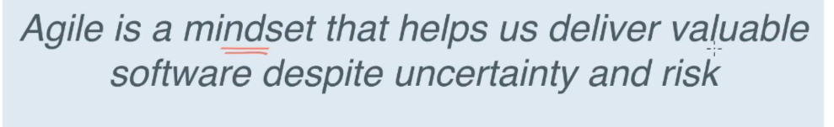

Agile mindset

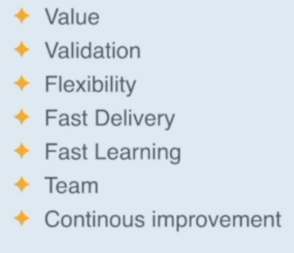

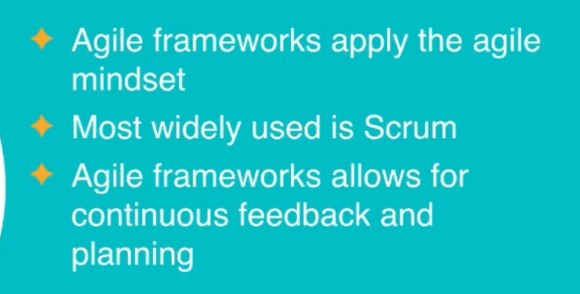

The Backlog

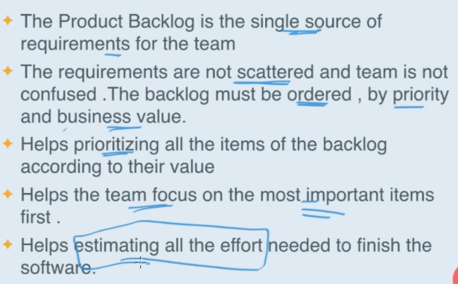

Definition Of Done

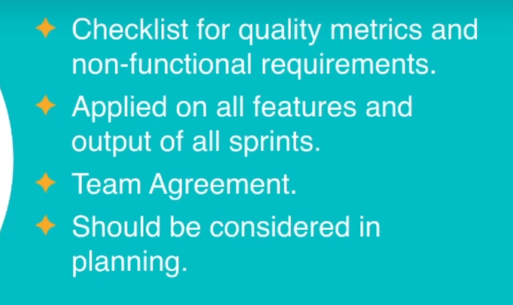

User Story Writing

